**System Requirements**

**Platform Requirement:** Laravel, jQuery

**Design Requirement:** The UI should be designed using Bootstrap 4

**Database Requirement:** All data should be stored in a JSON file and populated from JSON file too, but the image can be stored in a directory

**Functional Requirements:**

**Function ID:** 01

**Function Title:** Upload Image

**Function Description:** System will allow user to upload image to the system by following below:

* User can upload image via the modal by selecting or drag and drop
* User can enter a title of the image
* System will allow only PNG file to upload
* System will allow maximum 5MB size image to upload
* File should be uploaded by AJAX
* System will show a progress bar when the image is being uploaded
* After uploading the image will be shown to the list in descending order by time but the modal will not be disappeared
* After uploading the modal will be reset to allow to upload new image

**Wireframe:**

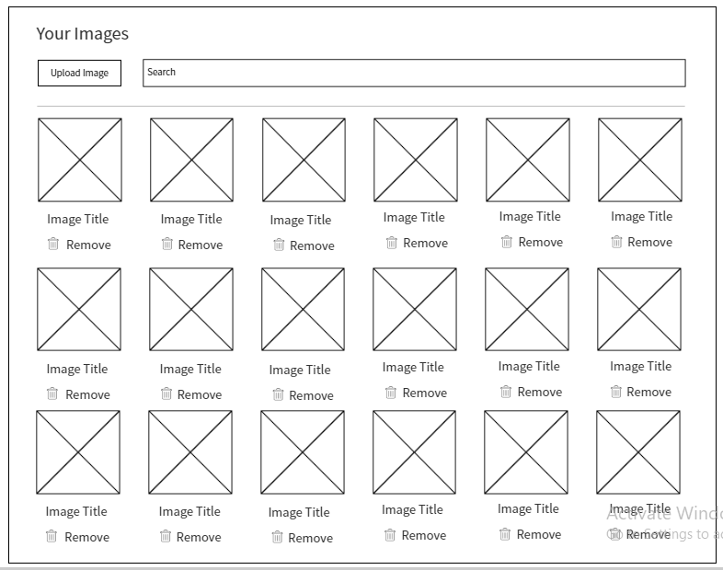

**Function ID:** 02

**Function Title:** Listing Images

**Function Description:** System will allow user to see all uploaded images in a view:

* Whatever the image dimension is, system should fit it in the image thumb in a nice view
* If the image title is so long and does not fit in it’s width then it should animate left to right and again right to left

**Wireframe**:

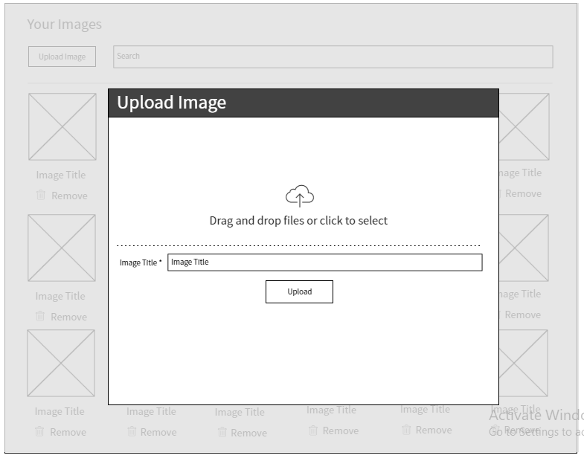

**Function ID:** 03

**Function Title:** Search Images

**Function Description:** System will allow user to search image by title:

* System will show the search result instantly based on the typed letters

NB: Mention that this will not be an AJAX search, you should load the JSON file as a string and populate the search result by JS

**Function ID:** 04

**Function Title:** Preview Images

**Function Description:** System will allow user preview an image by clicking on it using a nice preview plugin.

**Function ID:** 05

**Function Title:** Remove Images

**Function Description:** System will allow user remove an image by clicking on the remove button taking confirmation using sweetalert. System should also remove the remove from directory too.